TimeNex Integration with SAP in Naufar Hospital

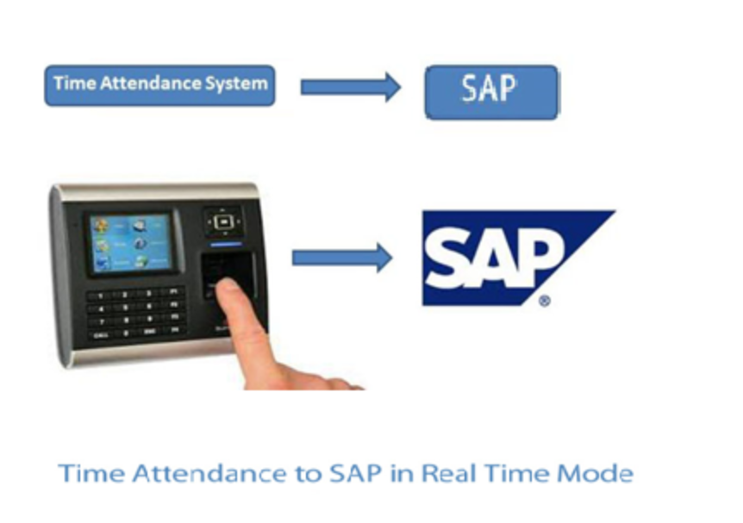
Payroll management is an imperative function of HR in any organization irrespective of its size. It is critical for the employees and organization for the payroll to be accurate and on time. Traditional method of utilizing manpower resources for payroll processing activities needlessly decreases efficiency of strategic contribution. Such tactical activities by human intervention are prone to be inaccurate and ultimately rife with errors.
It is blatant to have meticulous attention to detail of each event and seamlessly integrate it with payroll to get reliable and precise results. The inputs are attendance data of employees. To ensure accurate reporting of attendance and minimize human errors, process of time-attendance integration with payroll software must be automated. This integration can save a lot of time, money, ensure timely salary payments, improve productivity and employee satisfaction.
TimeNex Time-Attendance is a fully integrated and automated solution starting from recording punch data to generating reports or payroll integration. Its different software integration options facilitate organization to integrate it with any third party software SAP, Sage VIP etc. Once the data is received and processed in TimeNex Database, three different modes of integration are used to supply the attendance data in other software application/database. The three integration methods are as following(Graph 1):
- Database to Database
- API (Application Programming Interface)
- Customized Export Templates
The data can be supplied through push or pull method, as per business requirement.
Proposal for Naufar Hospital:
TimeNex can easily be integrated with SAP by using push or pull method. In case of Naufar Hospital, we proposed a third method (Customized export templates) to upload flat file/Time Sheet from TimeNex server onto filesystem/storage area behind DMZ/firewall using automated FTP. However API(option 2) could also be used to integrate TimeNex with SAP in Naufar defending on local IT infrastructure. Option # 1(database to database) is however not recommended in this case. For security reasons, the two servers will be authenticated with each other using one-way traffic between designated IP address. The flat file will be in a specific format (graph 2) as per the relevant Infotype (e.g 2011). SAP Application will pick the data. This process could be done manually, if needed at times, by using Transaction code SE30 and utilizing Program RPTEUP10. This entire process will be automated to near real-time frequency, if desired. This automated process of Time Management process will also have the ability to entertain manual entries/updates as the need arise (employee miss entry etc).
All Manual entries will be highlighted in different reports, for audit purpose only, and will behave exactly like normal entry for the purpose of payroll calculation/time Management.

Graph 1
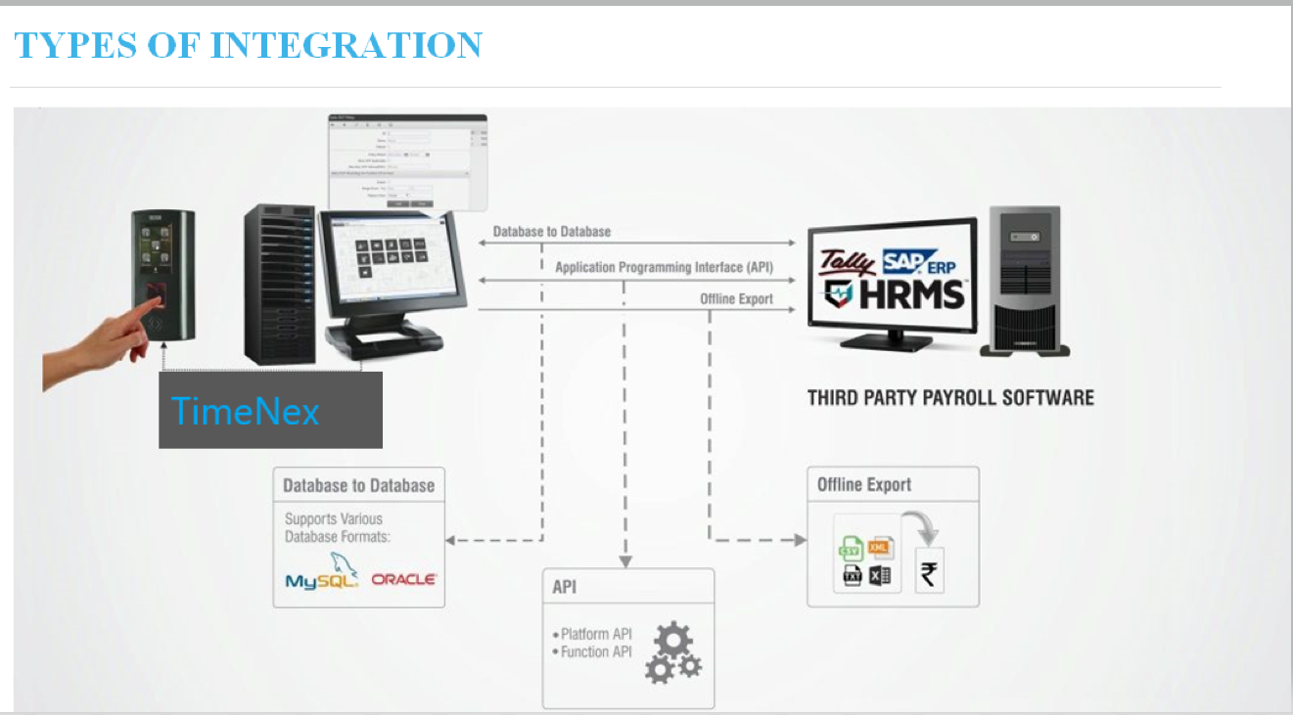

Graph 2
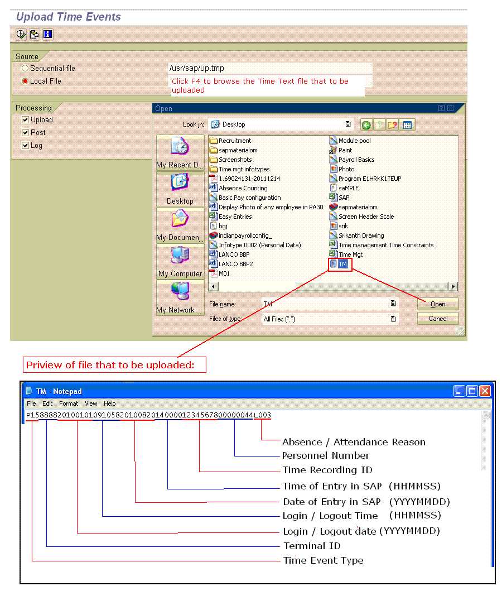
Error Log:
Error log of the timesheets uploads can be monitored and checked to the PERNER number level via Transaction code PT40 as illustrated below in Pic 2.
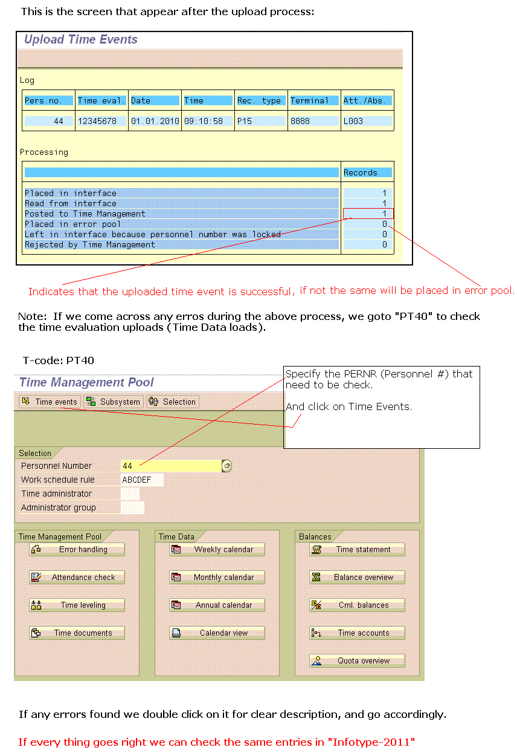
Benefits of Attendance system integration with SAP (Payroll)
Listed below are the ways in which an Naufar Hospital can benefit through seamless integration of TimeNex with SAP:
- Accurate Attendance Data Transfer to Payroll Software
- Smooth and Quick Payroll Processing
- Minimized Human Intervention
- Reduced Time Spent on Payroll Processing
- Reduced Erroneous Payroll
- Timely Salary Payments
- Increase in Overall Productivity

